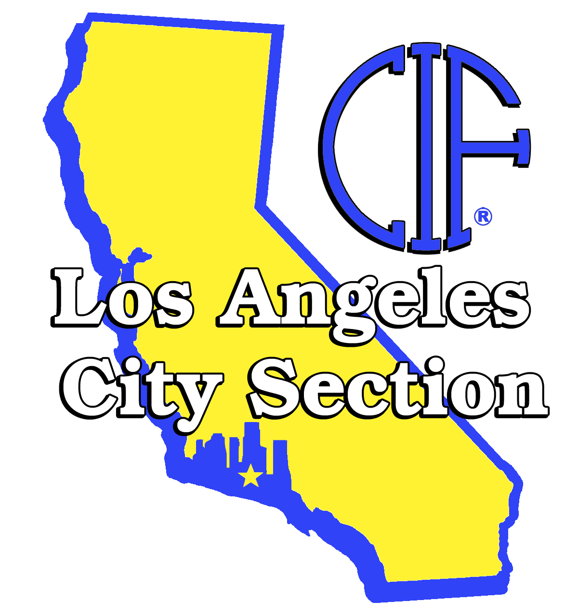

CIF LOS ANGELES CITY SECTION
1545 Wilshire Blvd., Suite 200, Los Angeles, CA 90017
Phone: (213) 207-2200 Fax (213) 207-2209
Web site: www.cif-la.org

TO: SELECTED ATHLETIC DIRECTOR

FROM: John A. Aguirre, Assistant Commissioner
CIF Los Angeles City Section

April 20, 2010

CIF LOS ANGELES CITY SECTION
2009-10 KENNY FAGINS, TOYOTA – SHAKE FOR SPORTSMANSHIP AWARD
List of Award Recipients

League School Athletic Director Student’s Name Grade Sports

Coliseum Fremont HS Amy McCabe Lafont Tolliver 12th Football, Bkb, Track
Crosstown Los Angeles Leadership Dia Adilifu Fountain Jennifer Hernandez 12th CC, Soccer, Track
East Valley Arleta HS James Magee Danny Velarde 12th Football
Eastern Roosevelt HS Mike Flores Aurora Torres 12th Basketball
Freeway Orthopaedic Magnet Gabriel Gonzalez Jacqueline Flores 12th Basketball / Softball
Marine Washington Prep Kim Bly Reshanda Gray 11th Basketball
Northern Belmont HS Carol Cracchiolo Alan Barrera 12th Wrestling
Ocean Marlton Ernie Epps Guillermina Valenzuela 11th Basketball
Southern Santee EC Tina Tamura Charlene Quintanilla 11th Track & Cross country
Valley Vaughn Charter David Cory Martha Medina 12th Volleyball
Valley Mission Reseda HS Scott Foley Anthony Chan 12th Swimming / H2O Polo
Western University HS Jim Nakabara Keilah Martinez 12th Volleyball
West Valley Taft HS Mark Drucker Matt Smit 12th Baseball

John Aguirre, Assistant Commissioner, will represent the CIF Los Angeles City Section and accompany the award recipients during the pre-game presentation.
Los Angeles Unified School District - Interscholastic Athletics Office
1545 Wilshire Blvd., Suite 200, Los Angeles, California 90017, Phone (213) 207-2200 • FAX (213) 207-2209
CIF LOS ANGELES CITY SECTION
2009-10 KENNY FAGINS, TOYOTA – SHAKE FOR SPORTSMANSHIP AWARD

Congratulations, your school has been selected by your league as the Kenny Fagin’s, Toyota - Shake for Sportsmanship Award recipient. This annual award presentation recognizes one school from each league in the CIF Los Angeles City Section and the CIF Southern Section that has show exemplary character and sportsmanship during the fall, winter and spring seasons.

The Shake for Sportsmanship Award Presentation will be held Thursday, April 29, during the pregame ceremony at Dodger Stadium. Each school must select a student-athlete to represent their school who will be introduced during the award ceremony. Using the attached form, please provide the name, sport and grade level of the student representing your school.

The CIF Los Angeles City Section appreciate the efforts of the Los Angeles Dodgers to recognize the recipients of the Kenny Fagin’s - Toyota Shake for Sportsmanship Awards during their pre-game ceremony. It is our expectation to reciprocate this effort with a 100% attendance by selected school representatives. Should you have any questions or concerns contact John Aguirre in the Athletics Office.

KENNY FAGINS – CIF LOS ANGELES CITY SECTION
TOYOTA SHAKE FOR SPORTSMANSHIP AWARD CEREMONY

THURSDAY, APRIL 29, 5:30 PM
Dodger Stadium
Meet in Parking Lot Behind Center Field
DODGERS VS. PITTSBURG

SEE YOU AT THE BALL PARK!

